**INSTA APACHE SPARK ON WINDOWS 10**

1. Instal Scala: Download Scala dari link: <http://downloads.lightbend.com/scala/2.11.8/scala-2.11.8.msi>
2. Tetapkan variabel lingkungan:
3. user variable:

Variable: SCALA_HOME;

Value: C:\Program Files (x86)\scala

1. system variable

Variable: PATH

Value: C:\Program Files (x86)\scala\bin

1. selanjutnya check di cmd

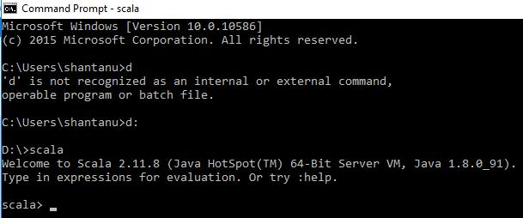

1. instal java download java di link bawah ini:

<http://www.oracle.com/technetwork/java/javase/downloads/jdk8-downloads-2133151.html>

a. set envirotment variabels :

* + 1. User variable:

Variable: JAVA_HOME

Value: C:\Program Files\Java\jdk1.8.0_91

* + 1. System variable:

Variable: PATH

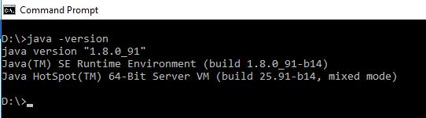Value: C:\Program Files\Java\jdk1.8.0_91\bin

b. check di cmd

1. instal eclipse mars download dari link di bawah ini

[https://eclipse.org/downloads/](https://eclipse.org/downloads/%20)andextract it into Cdrive.

a. Set environmental variables:

* + 1. User variable:

Variable: ECLIPSE_HOME

Value: C:\eclipse

* + 1. System variable:

Variable: PATH

Value: C:\eclipse \bin

1. Instal apache spark dari link ini:

<http://spark.apache.org/downloads.html>andextract it into D drive, such as D:\Spark.

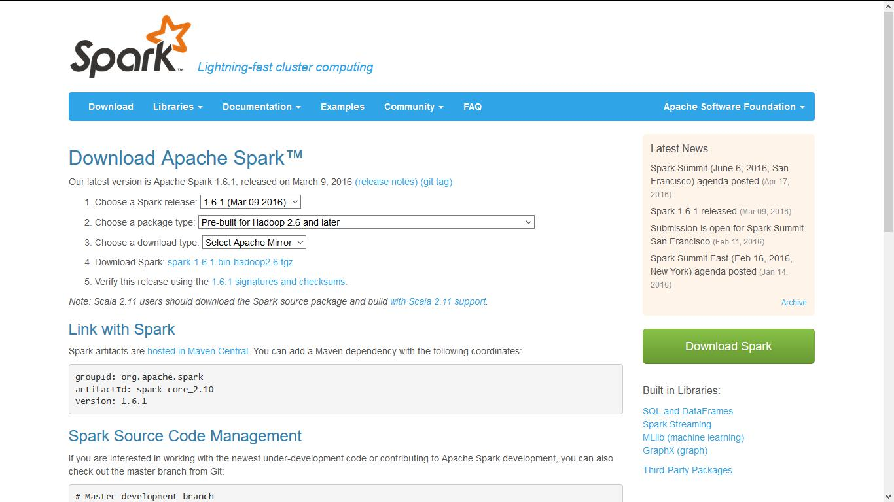

1. Set environmental variables:
   1. User variable:

Variable: SPARK_HOME

Value: D:\spark\spark-1.6.1-bin-hadoop2.6

* 1. System variable:

Variable: PATH

Value: D:\spark\spark-1.6.1-bin-hadoop2.6\bin

1. Download Windows Utilities: Download dari link di bawah ini:

<https://github.com/steveloughran/winutils/tree/master/hadoop-2.6.0/bin> dan tempatan di D:\spark\spark-1.6.1-bin-hadoop2.6\bin

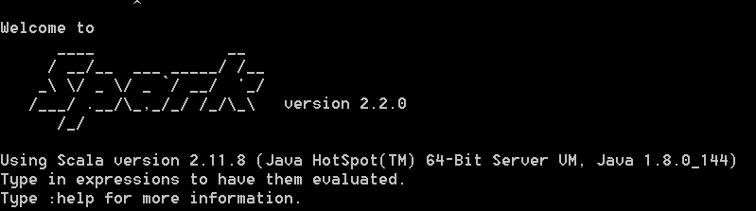

**6.** Install Maven 3.3.Download Apache-Maven-3.3.9 dari link:<http://apache.mivzakim.net/maven/maven-3/3.3.9/binaries/apache-maven-3.3.9-bin.zip>

Extract file D drive, such as D:\apache-maven-3.3.9

* 1. Set Environmental variables:
     1. User variable

Variable: MAVEN_HOME

Value: D:\apache-maven-3.3.9

* + 1. System variable

Variable: Path

Value: D:\apache-maven-3.3.9\bin